TITLE
Jane Example¹, John Example²*
¹Affiliation
²Affiliation
*corresponding author, email address
Abstract
Abstract writing is an art and a science that requires both creativity and rigor. An abstract should summarize the main contributions and findings of a paper in a clear and concise way, while also capturing the attention and interest of the readers. However, writing an abstract can be challenging, especially when the word limit is tight and the topic is complex. In this paper, we present some tips and tricks for writing effective abstracts that can make your paper stand out from the crowd. We also provide some examples of good and bad abstracts, and explain what makes them so. Finally, we discuss some common pitfalls and mistakes to avoid when writing abstracts, and how to overcome them. We hope that this paper will help you improve your abstract writing skills and increase your chances of getting accepted to your desired conference. (Please do not exceed 200 words.)
Biography (required only for lectures, delete this section if you have a poster)
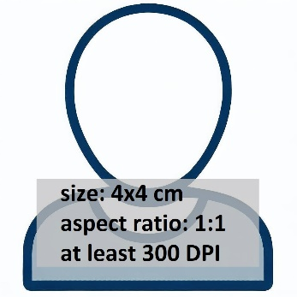
Jane Example
Please write a short biography here. It should contain your main research area, workplace(es), etc. Also provide a picture of you. (Please do not exceed 80 words.)

John Example
Same as above. (Please do not exceed 80 words.)

